My Op Art

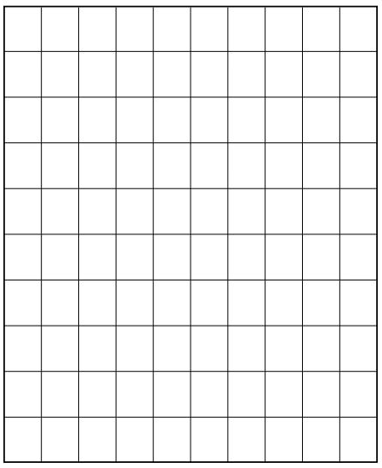

Color | Number | Fraction | Decimal | Percent

My Op Art

Color | Number | Fraction

