From Developing Number Sense, Grades 3–6 by Rusty Bresser and Caren Holtzman

Oh No! 99!

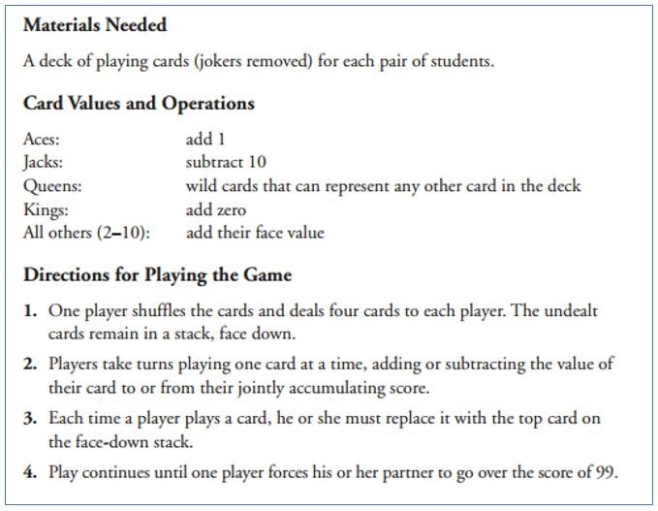

Class discussions afterwards

Good prompts to start with:
My strategy is . . .
The best cards are . . .
I like to play because . . .

